CAPSTONE PROJECT PROPOSAL REPORT

Project Title: Aarogya Sathi: A Personalized, Multilingual, and Hyper-Localized Healthcare Assistant for Urban India

Domain: Artificial Intelligence, Natural Language Processing (NLP), and Multi-Agent Systems

1. Executive Summary
In the rapidly evolving landscape of urban India, fast-paced lifestyles, long working hours, and environmental stressors have led to a critical neglect of personal health. Existing digital health solutions fail to provide personalized care, often relying on generalized western health paradigms, expensive subscription models, or platforms owned by foreign entities that compromise sensitive user data.
Aarogya Sathi addresses this critical gap as an advanced, privacy-first, multi-modal AI healthcare assistant designed to function as a "Virtual Nurse." Built on a specialized multi-model architecture, it seamlessly coordinates three distinct AI agents dedicated to conversational dialogue, real-time vernacular translation, and expert medical analysis. By integrating real-time hyper-local environmental data (such as Delhi’s air quality indices or Mumbai’s humidity levels) alongside personalized activity tracking and "Medi-Minder" medication scheduling, Aarogya Sathi delivers contextualized wellness and dietary insights. The system enforces strict data sovereignty by processing and storing sensitive medical data locally, shifting urban healthcare from reactive management to proactive, early disease detection.

2. Problem Statement & Market Gap

2.1 The Urban Health Crisis
Residents of major Indian metropolitan areas face unique health challenges driven by high pollution, fluctuating weather patterns, stress, and irregular schedules. Managing personal health often takes a backseat, leading to a rise in chronic lifestyle conditions.

2.2 Shortcomings of Existing Solutions
An evaluation of current health and fitness applications reveals several structural deficiencies:
- Lack of Localization: Most platforms offer generalized advice that ignores local environmental factors like regional weather, pollution spikes, and culturally specific dietary habits.
- Language and Literacy Barriers: The vast majority of comprehensive health applications operate exclusively in English, isolating a significant portion of the population who struggle to express complex medical symptoms in a non-native language.
- The Data Privacy Deficit: Many mainstream applications are managed by foreign entities. This introduces massive privacy risks regarding the monetization and cross-border transfer of sensitive personal health information (PHI).

2.3 Market Comparison Matrix
Feature | Generic Health Apps | Aarogya Sathi
Primary Language | English-centric | Multilingual (Native Indian Languages)
Data Storage | Cloud-based (Often Foreign Servers) | Localized / Data Sovereignty Enforced
Context Awareness | Standardized (Western/Global) | Hyper-Localized (AQI, Humidity, Local Diet)
Core Architecture | Monolithic / Single API dependent | Multi-Model (Talk, Translate, Medical Expert)
Feature Integration | Siloed (Just tracking or just telehealth) | Unified Vitals Tracking + Medi-Minder + AI Diagnostics

3. Project Objectives & Scope
The primary objective of this capstone project is to develop an intelligent, secure, and highly accessible healthcare ecosystem tailored for Indian demographics.

3.1 Core Objectives
- Develop a Multi-Model AI Framework: Implement an interconnected multi-agent framework where specialized models handle communication, translation, and medical inference independently.
- Mitigate Language Barriers: Enable natural, conversational symptom reporting and advice delivery in vernacular Indian languages.
- Incorporate Environmental Contextualization: Establish pipelines to ingest real-time local weather and air quality metrics to adjust lifestyle and preventative health recommendations dynamically.
- Ensure Data Sovereignty: Engineer a secure local-first data infrastructure to keep user records protected and retained within national borders.
- Promote Proactive Wellness: Integrate daily habit tracking and medication adherence systems to assist users in early disease prevention.

4. System Architecture & Technical Methodology

Aarogya Sathi is engineered around a comprehensive mobile application layer powered by a decentralized, multi-agent backend. Rather than relying on a single monolithic language model, the system divides computational tasks among specialized AI nodes.

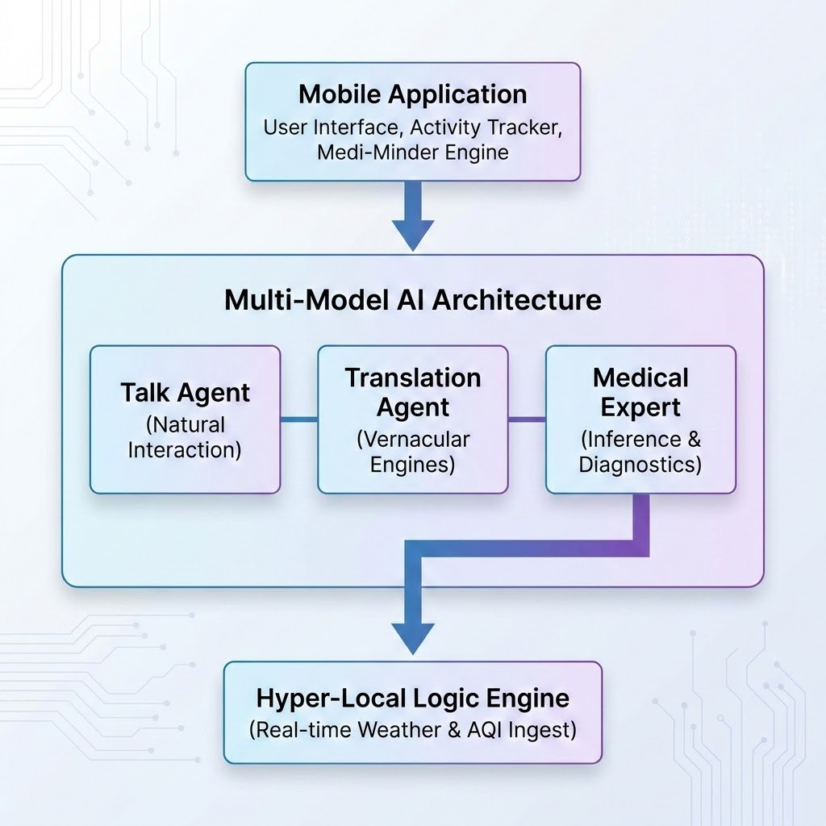

4.1 The Multi-Model Blueprint
The backend architecture splits intelligence into three core operational pipelines:
- The Talk Agent: Handles natural, empathetic human-computer interaction, managing conversation state, user engagement, and behavioral context.
- The Translation Agent: Acts as a real-time linguistic middle-layer. It translates complex vernacular descriptions into standardized tokens for processing, and converts technical medical outputs back into simple, localized dialects.
- The Medical Expert Agent: A highly secure inference node trained to cross-reference reported symptoms, historical user records, and lifestyle baselines to generate accurate health assessments.

4.2 Data Flow and Processing Pipeline
- Input Ingestion: The user interacts with the app via text or voice in their native language. Simultaneously, the application background worker fetches current localized sensor metrics (such as geolocation-based air quality index).
- Contextual Refinement: The Translation Agent normalizes the input, while the Hyper-Local Logic Engine attaches environmental parameters to the payload.
- Inference & Action Generation: The Medical Expert Agent processes the combined payload to evaluate risks, log information to the user's localized trend timeline, and return safe, actionable guidance.

5. Core Modules & Key Features

5.1 Hyper-Localized Health Logic
Aarogya Sathi protects health by analyzing the direct environment of the user. The platform ingests localized parameters to scale advice dynamically:
- Delhi/Northern Region Focus: Monitors extreme air quality index (AQI) fluctuations to issue preemptive warnings for respiratory health, suggesting targeted indoor breathing patterns or specific dietary updates to counter inflammation.
- Mumbai/Coastal Region Focus: Factors high humidity indexes and seasonal monsoon shifts into its core logic, updating optimal hydration requirements and warning against regional waterborne risks or specific heavy foods.

5.2 Multilingual Conversational Interface
Medical terminology can be alienating. Aarogya Sathi features a comprehensive Natural Language Processing framework supporting multiple regional Indian languages. Users can explain complex or sensitive symptoms naturally, exactly how they feel, avoiding rigid medical jargon or language barriers.

5.3 Integrated Routine & Medication Management (Medi-Minder)
To transition healthcare from reactive emergency treatment to continuous wellness support, the system deploys a dual tracking layer:
- Activity Tracking: Monitors day-to-day user habits, steps, and baseline behavioral trends.
- Medi-Minder: A smart scheduling utility that manages precise medication timelines. Rather than sounding static alarms, it weaves reminders contextually into daily health conversations and dynamically adjusts lifestyle tips based on adherence trends.

Data Sovereignty Architecture Note: > Unlike traditional cloud platforms, Aarogya Sathi is architected around a privacy-first local storage standard. Sensitive metrics, personal health indices, and medical logs are processed locally. This eliminates exposure to third-party servers, guaranteeing absolute data privacy and establishing a secure architecture resistant to foreign surveillance and commercial data farming.

6. Expected Outcomes & Public Health Impact

6.1 Early Disease Detection
By maintaining continuous, hyper-localized oversight of subtle physiological changes and medication habits, Aarogya Sathi enables early disease detection. It flags irregular health baselines long before conditions escalate into critical medical emergencies.

6.2 Bridging the Healthcare Ecosystem Gap
The application serves as a crucial infrastructure layer connecting ordinary citizens with complex medical networks. By offering immediate, trusted, and localized guidance, it reduces panic-driven hospital visits for minor issues while ensuring users know exactly when professional clinical intervention is genuinely required.

7. Implementation Roadmap & Milestones

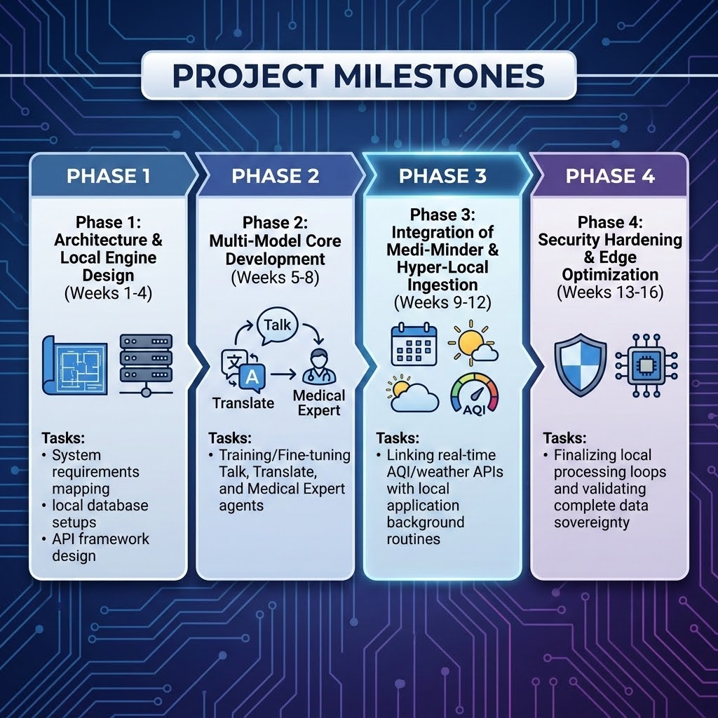

8. Conclusion
Aarogya Sathi represents a significant step forward in personalized digital health infrastructure. By combining cutting-edge multi-model AI orchestration with deep local awareness, multi-lingual inclusivity, and strict data privacy, it delivers a robust, accessible, and viable solution tailored specifically to the unique needs of the Indian urban population. This project demonstrates high technical merit and clear public health utility, making it an ideal candidate for capstone selection.

